ECE361 – Computer Networks

Wireshark Lab 1: HTTP

First Name: Ho Seok Last Name: Lee

First Name: Neehar Last Name: Kantimahanti

Group Details:
Student #: 104112177 Student #: 1003872286
Mark:
 | Question | Answer
1 | Is your browser running HTTP version 1.0 or 1.1? What version of HTTP is the  server running? | Browser: HTTP/1.1  Server: HTTP/1.1
Annotated Screenshot (if needed)
2 | What languages (if any) does your browser indicate that it can accept to the  server? | Accepted Languages: en-CA, en
Annotated Screenshot (if needed)
3 | What is the IP address of your computer? Of the gaia.cs.umass.edu server? | Computer: 192.168.1.13  Server: 128.119.245.12
Annotated Screenshot (if needed) | 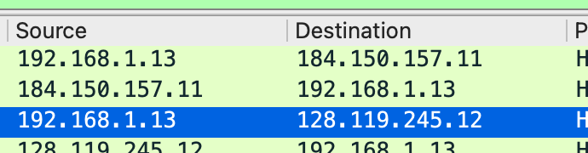
4 | What is the status code returned from the server to your browser? | Status Code: 200
Annotated Screenshot (if needed) | 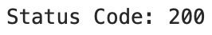
5 | When was the HTML file that you are retrieving last modified at the server? | Last Modified: Friday 8th October 2021, 5:59:01 GMT
Annotated Screenshot (if needed)
6 | How many bytes of content are being returned to your browser? | Content Length: 128 bytes
Annotated Screenshot (if needed) | 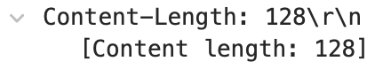
7 | By inspecting the raw data in the packet content window, do you see any headers within the data that are not displayed in the packet-listing window? If so, name one. | No
Annotated Screenshot (if needed)
8 | Inspect the contents of the first HTTP GET request from your browser to the  server. Do you see an “IF-MODIFIED-SINCE” line in the HTTP GET? | No
Annotated Screenshot (if needed)
9 | Inspect the contents of the server response. Did the server explicitly return the contents of the file? How can you tell? | Yes, under the Line-based text data section
Annotated Screenshot (if needed) | 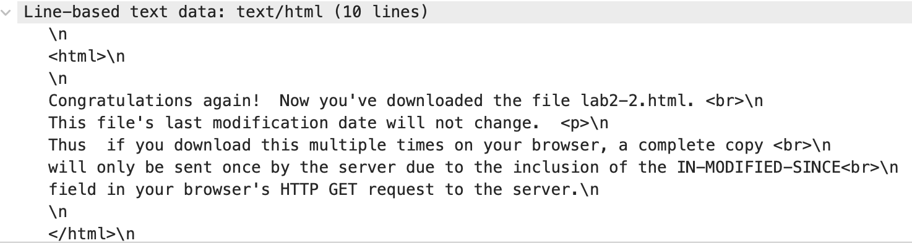
10 | Now inspect the contents of the second HTTP GET request from your browser to the server. Do you see an “IF-MODIFIED-SINCE:” line in the HTTP GET? If so, what information follows the “IF-MODIFIED-SINCE:” header? | Yes, the last modified date  Friday 8th October 2021, 5:59:01 GMT
Annotated Screenshot (if needed)
11 | What is the HTTP status code and phrase returned from the server in response to this second HTTP GET? Did the server explicitly return the contents of the file?  Explain. | Status Code: 304  Response Phrase: Not Modified  The server did not explicitly return the contents again as it hasn’t been modified since the last GET request. It can be pulled from the cache.
Annotated Screenshot (if needed) | 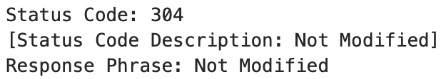
12 | How many HTTP GET request messages were sent by your browser? | Number of Requests: 1
Annotated Screenshot (if needed)
13 | How many data-containing TCP segments were needed to carry the single HTTP response? | Number of TCP Segments: 6
Annotated Screenshot (if needed) | 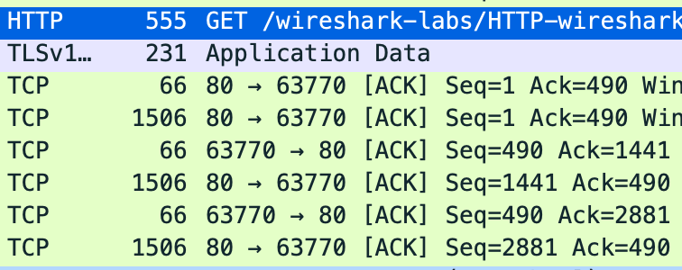
14 | What is the status code and phrase associated with the response to the HTTP GET request? | Status Code: 200  Response Phrase: OK
Annotated Screenshot (if needed) | 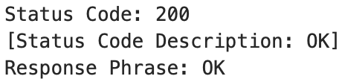
15 | Are there any HTTP status lines in the transmitted data associated with a TCP induced “Continuation”? | No
Annotated Screenshot (if needed)
16 | How many HTTP GET request messages were sent by your browser? To which Internet addresses were these GET requests sent? | Number of Requests: 4  Addresses:  http://gaia.cs.umass.edu/wireshark-labs/HTTP-wireshark-file4.html  http://gaia.cs.umass.edu/pearson.png  http://kurose.cslash.net/8E_cover_small.jpg  http://r3.o.lencr.org/MFgwVqADAgEA...
Annotated Screenshot (if needed) | 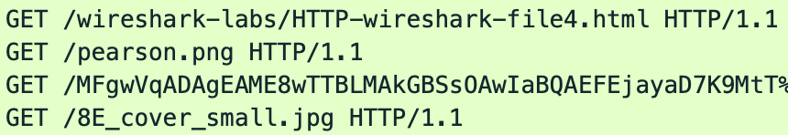
17 | Can you tell whether your browser downloaded the two images serially, or  whether they were downloaded from the two web sites in parallel? Explain. | Although it may seem like the download happened serially (since one downloaded after the other), they should be happening in parallel.
Annotated Screenshot (if needed)
Questions 18 and 19 omitted

Yes, questions 12 through 15 are different in this document than the lab handout. You must answer the questions found in this document.

